Introduction To Neural Networks

Neural networks are machine learning models that mimic the complex functions of the human brain. These models consist of interconnected nodes or neurons that process data, learn patterns directly from data without relying on pre-defined rules, enabling them to perform tasks such as pattern recognition and decision-making.
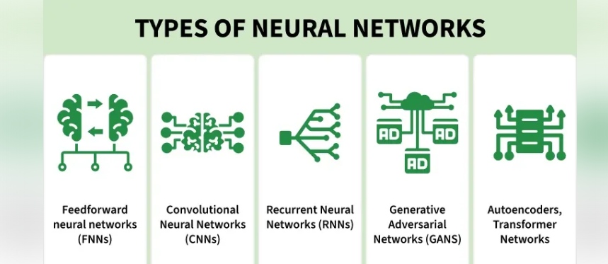
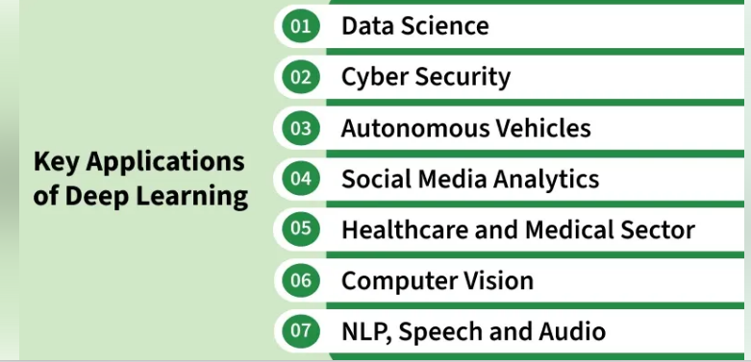
Neural Networks are built from several key components:
- Neurons: The basic units that receive inputs, each neuron is governed by a threshold and an activation function.
- Connections: Links between neurons that carry information, regulated by weights and biases.
- Weights and Biases: These parameters determine the strength and influence of connections.
- Propagation Functions: Mechanisms that help process and transfer data across layers of neurons.
- Learning Rule: The method that adjusts weights and biases over time to improve accuracy.
Learning in neural networks follows a structured, three-stage process:
- Input Computation: Data is fed into the network.
- Output Generation: Based on the current parameters, the network generates an output.
- Iterative Refinement: The network refines its output by adjusting weights and biases, gradually improving its performance on diverse tasks.

The image illustrates the analogy between a biological neuron and an artificial neuron, showing how inputs are received and processed to produce outputs in both systems.

Importance of Neural Networks
- Identify Complex Patterns: Recognize intricate structures and relationships in data; adapt to dynamic and changing environments.
- Learn from Data: Handle vast datasets efficiently; improve performance with experience and retraining.
- Drive Key Technologies: Power natural language processing (NLP); enable self-driving vehicles; support automated decision-making systems.
- Boost Efficiency: Streamline workflows and processes; enhance productivity across industries.
- Backbone of AI: Serve as the core driver of artificial intelligence progress; continue shaping the future of technology and innovation.

Layers in Neural Network Architecture
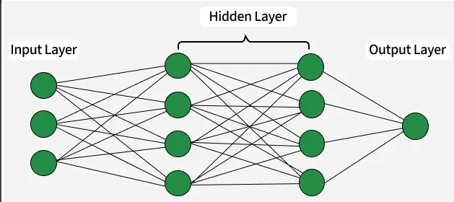
Layers in Neural Network Architecture
- Input Layer: This is where the network receives its input data. Each input neuron in the layer corresponds to a feature in the input data.
- Hidden Layers: These layers perform most of the computational heavy lifting. A neural network can have one or multiple hidden layers. Each layer consists of units (neurons) that transform the inputs into something that the output layer can use.
- Output Layer: The final layer produces the output of the model. The format of these outputs varies depending on the specific task like classification, regression.

Working of Neural Networks

1. Forward Propagation
When data is input into the network, it passes through the network in the forward direction, from the input layer through the hidden layers to the output layer. This process is known as forward propagation. Here’s what happens during this phase:
1. Linear Transformation: Each neuron in a layer receives inputs which are multiplied by the weights associated with the connections. These products are summed together and a bias is added to the sum. This can be represented mathematically as:
z = w_1x_1 + w_2x_2 + \ldots + w_nx_n + b
where
- w represents the weights
- x represents the inputs
- b is the bias
2. Activation: The result of the linear transformation (denoted as z) is then passed through an activation function. The activation function is crucial because it introduces non-linearity into the system, enabling the network to learn more complex patterns. Popular activation functions include ReLU, sigmoid and tanh.

2. Backpropagation
After forward propagation, the network evaluates its performance using a loss function which measures the difference between the actual output and the predicted output. The goal of training is to minimize this loss. This is where backpropagation comes into play:
- Loss Calculation: The network calculates the loss which provides a measure of error in the predictions. The loss function could vary; common choices are mean squared error for regression tasks or cross-entropy loss for classification.
- Gradient Calculation: The network computes the gradients of the loss function with respect to each weight and bias in the network. This involves applying the chain rule of calculus to find out how much each part of the output error can be attributed to each weight and bias.
- Weight Update: Once the gradients are calculated, the weights and biases are updated using an optimization algorithm like stochastic gradient descent (SGD). The weights are adjusted in the opposite direction of the gradient to minimize the loss. The size of the step taken in each update is determined by the learning rate.

3. Iteration
This process of forward propagation, loss calculation, backpropagation and weight update is repeated for many iterations over the dataset. Over time, this iterative process reduces the loss and the network's predictions become more accurate.
Through these steps, neural networks can adapt their parameters to better approximate the relationships in the data, thereby improving their performance on tasks such as classification, regression or any other predictive modeling.

Example of Email Classification
Let's consider a record of an email dataset:
Email ID | Email Content | Sender | Subject Line | Label
1 | "Get free gift cards now!" | spam@example.com | "Exclusive Offer" | 1
To classify this email, we will create a feature vector based on the analysis of keywords such as "free" "win" and "offer"
The resulting feature vector is:
- free: Present (1)
- win: Absent (0)
- offer: Present (1)
Feature Vector:
[1, 0, 1]
The feature vector is passed through the neural network, where each neuron computes a weighted sum of the inputs and applies an activation function to produce its output.
Hidden Layer Calculation:
Assume the hidden layer contains two neurons with the following weights
- Neuron H1: [ 0.5, −0.2, 0.3]
- Neuron H2: [ 0.4, 0.1, −0.5]
For the input vector [1, 0, 1], the weighted sums are:
- For H1: (1 × 0.5) +(0 ×− 0.2) + ( 1 × 0.3) = 0.5 + 0+ 0.3 = 0.8
- For H2: (1 × 0.4) +(0 × 0.1) + ( 1 × −0.5) = 0.4 + 0 −0.5 =−0.1
Applying the ReLU activation function:
- H1 Output: ReLU(0.8) = 0.8
- H2 Output: ReLu(-0.1) = 0
Output Layer: The outputs from the hidden layer are then passed to the output neuron.
- Output Weights: [0.7, 0.2]
- Input from Hidden Layer: [0.8, 0]
- Weighted Sum: (0.8×0.7)+(0×0.2)=0.56+0=0.56
- Activation (Sigmoid): \sigma(0.56) = \frac{1}{1 + e^{-0.56}} \approx 0.636
Final Classification:
- The output value of approximately 0.636 indicates the probability of the email being spam.
- Since this value is greater than 0.5, the neural network classifies the email as spam (1).
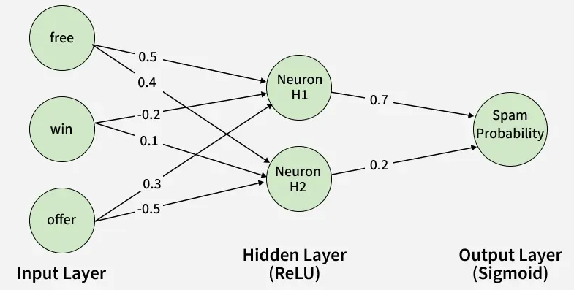
Neural Network

Learning of a Neural Network

1. Learning with Supervised Learning
In supervised learning, a neural network learns from labeled input-output pairs provided by a teacher. The network generates outputs based on inputs and by comparing these outputs to the known desired outputs, an error signal is created. The network iteratively adjusts its parameters to minimize errors until it reaches an acceptable performance level.

2. Learning with Unsupervised Learning
Unsupervised learning involves data without labeled output variables. The primary goal is to understand the underlying structure of the input data (X). Unlike supervised learning, there is no instructor to guide the process. Instead, the focus is on modeling data patterns and relationships, with techniques like clustering and association commonly used.

3. Learning with Reinforcement Learning
Reinforcement learning enables a neural network to learn through interaction with its environment. The network receives feedback in the form of rewards or penalties, guiding it to find an optimal policy or strategy that maximizes cumulative rewards over time. This approach is widely used in applications like gaming and decision-making.

Types of Neural Networks
There are several types of neural networks, including:
- Feedforward Networks: It is a simple artificial neural network architecture in which data moves from input to output in a single direction.
- Singlelayer Perceptron: It has one layer and it applies weights, sums inputs and uses activation to produce output.
- Multilayer Perceptron (MLP): It is a type of feedforward neural network with three or more layers, including an input layer, one or more hidden layers and an output layer.
- Convolutional Neural Network (CNN): It is designed for image processing. It uses convolutional layers to automatically learn features from input images, enabling effective image recognition and classification.
- Recurrent Neural Network (RNN): Handles sequential data using feedback loops to retain context over time.
- Long Short-Term Memory (LSTM): A type of RNN with memory cells and gates to handle long-term dependencies and avoid vanishing gradients.

Implementation of Neural Network using TensorFlow
Here, we implement simple feedforward neural network that trains on a sample dataset and makes predictions using following steps:

Step 1: Import Necessary Libraries
Import necessary libraries, primarily TensorFlow and Keras, along with other required packages such as NumPy and Pandas for data handling.
Python
import numpy as np
import pandas as pd
from tensorflow.keras.models import Sequential
from tensorflow.keras.layers import Dense

Step 2: Create and Load Dataset
- Create or load a dataset. Convert the data into a format suitable for training (usually NumPy arrays).
- Define features (X) and labels (y).
Python
data = {
'feature1': [0.1, 0.2, 0.3, 0.4, 0.5],
'feature2': [0.5, 0.4, 0.3, 0.2, 0.1],
'label': [0, 0, 1, 1, 1]
}

df = pd.DataFrame(data)
X = df[['feature1', 'feature2']].values
y = df['label'].values

Step 3: Create a Neural Network
Instantiate a Sequential model and add layers. The input layer and hidden layers are typically created using Dense layers, specifying the number of neurons and activation functions.
Python
model = Sequential()
model.add(Dense(8, input_dim=2, activation='relu'))
model.add(Dense(1, activation='sigmoid'))

Step 4: Compiling the Model
Compile the model by specifying the loss function, optimizer and metrics to evaluate during training. Here we will use binary crossentropy and adam optimizer.
Python
model.compile(loss='binary_crossentropy',
optimizer='adam', metrics=['accuracy'])

Step 5: Train the Model
Fit the model on the training data, specifying the number of epochs and batch size. This step trains the neural network to learn from the input data.
Python
model.fit(X, y, epochs=100, batch_size=1, verbose=1)

Step 6: Make Predictions
Use the trained model to make predictions on new data. Process the output to interpret the predictions like converting probabilities to binary outcomes.
Python
test_data = np.array([[0.2, 0.4]])
prediction = model.predict(test_data)
predicted_label = (prediction > 0.5).astype(int)
Output:
Predicted label: 1

Applications
- Image and Video Recognition: CNNs are extensively used in applications such as facial recognition, autonomous driving and medical image analysis.
- Natural Language Processing (NLP): RNNs and transformers power language translation, chatbots and sentiment analysis.
- Finance: Predicting stock prices, fraud detection and risk management.
- Healthcare: Neural networks assist in diagnosing diseases, analyzing medical images and personalizing treatment plans.
- Gaming and Autonomous Systems: Neural networks enable real-time decision-making, enhancing user experience in video games and enabling autonomous systems like self-driving cars.

Advantages
- Can model complex relationships: Neural networks use non-linear activation functions to learn intricate patterns that cannot be captured by linear models.
- Automatic feature learning: They automatically extract relevant features from raw data, reducing the need for manual feature engineering.
- Supports parallel processing: Multiple neurons can perform computations simultaneously, improving computational efficiency, especially on GPUs.
- Generalizes to unseen data: Once trained, neural networks can make accurate predictions on new data that was not part of the training set.

Limitations
- Training large neural networks is computationally intensive and requires significant processing power.
- They act as black box models, making it difficult to understand how decisions are made, which can be a concern in critical applications.
- They may suffer from overfitting, where the model memorizes training data instead of learning general patterns, even though regularization can help reduce this issue.
- Neural networks often require large, well-labeled datasets for effective training and performance may suffer if the data is limited or biased.

ANN vs BNN

Artificial and biological neural networks are systems that process information using interconnected neurons. ANNs are inspired by the human brain, but differ from BNNs in structure, learning, and adaptability.

Artificial Neural Networks (ANNs)
Artificial Neural Networks are computational models inspired by the human brain, used in machine learning to recognize patterns and make predictions. They consist of layers (input, hidden, output) where data flows through weighted connections.
- Learn from data by adjusting weights using algorithms like backpropagation
- Work well for tasks like image recognition, NLP, and forecasting
- Require structured and large datasets for effective training
- Fast and efficient due to implementation on modern hardware (GPUs)

Biological Neural Networks (BNNs)
Biological Neural Networks are natural systems found in living organisms, particularly in the human brain. They consist of neurons with dendrites, a cell body, and an axon that communicate through electrochemical signals.
- Learn continuously from experience and environmental interaction
- Highly adaptive and capable of handling noisy, unstructured inputs
- Operate through massively parallel processing
- More energy-efficient and fault-tolerant than artificial systems

Comparison between ANN and BNN
Parameter | Artificial Neural Networks (ANN) | Biological Neural Networks (BNN)
Structure | Layered architecture: input layer, hidden layers, output layer | Network of neurons consisting of dendrites, cell body, and axon
Learning | Learns through algorithms by adjusting weights during training | Learns through experience and changes in synaptic connections
Data Handling | Requires structured and labeled data | Can process noisy and unstructured data
Processing | Digital, fast, and computation-based | Electrochemical, slower but massively parallel
Adaptability | Limited after training phase | Continuously adaptive and self-learning

Types of Neural Networks

Neural networks are available in different architectures, each designed to solve specific types of problems. The choice of architecture depends on the nature of the data and the task, such as image recognition, sequence modeling or pattern classification.
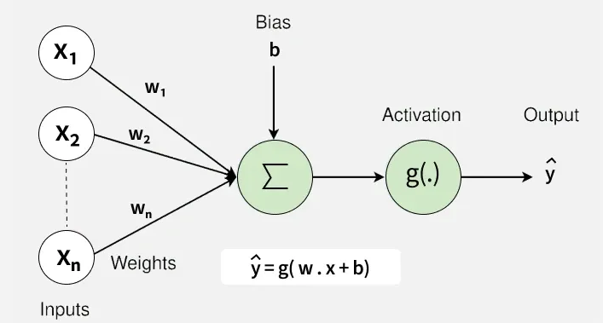
Neural Network basic framework

1. Feedforward Neural Networks
Feedforward neural networks are a type of artificial neural network where data flows in one direction from input to output without forming cycles. Inputs pass through hidden layers to produce outputs.
- Architecture: Consists of input, hidden and output layers with unidirectional data flow.
- Training: Typically trained using backpropagation to minimize prediction error.
- Applications: Used in image and speech recognition, NLP, financial forecasting and recommendation systems.
- When to use: Suitable for general tasks like classification and regression, especially when data is static and not sequential.
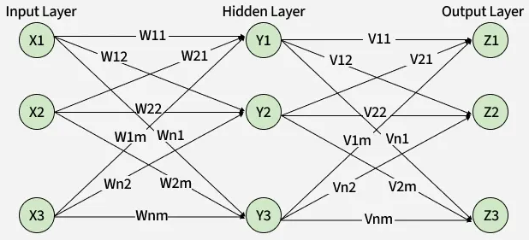
Feedforward Neural Networks

2. Convolutional Neural Networks (CNNs)
Convolutional neural networks are designed to process grid-like data such as images and videos. They use convolutional layers to detect patterns and capture spatial relationships.
- Key Components: Utilizing convolutional layers, pooling layers and fully connected layers.
- Applications: Image classification, object detection, medical imaging, autonomous driving and augmented reality.
- When to use: Ideal for tasks involving images, videos or grid-structured data.
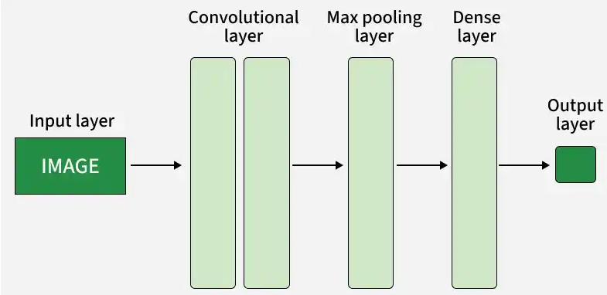
CNN

3. Recurrent Neural Networks (RNNs)
Recurrent neural network handles sequential data in which the current output is a result of previous inputs by looping over themselves to hold internal state (memory).
- Architecture: Includes recurrent connections that allow information to loop and capture sequence patterns.
- Challenges: Face issues like vanishing gradients, which limit learning long-term dependencies.
- Applications: Language translation, text classification, conversational systems and time series prediction.
- When to use: Suitable for tasks involving sequences such as text, speech or time series data.
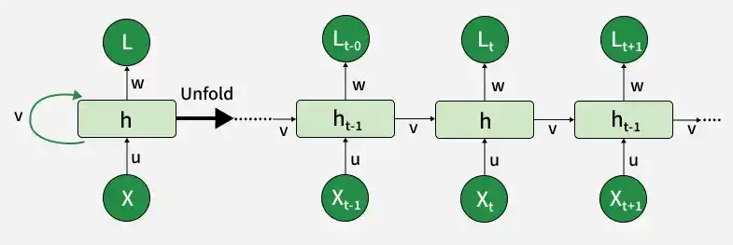
RNN

4. Long Short-Term Memory Networks (LSTMs)
Long Short-Term Memory Networks (LSTMs) are a variant of RNNs. They exhibit memory cells to solve the disappearing gradient issue and keep large ranges of information in their memory.
- Key Features: Capture memory cells in pass information flowing and vanishing gradient issue.
- Applications: Value of RNNs is in terms of importing long-term memory into the model like language translation and time-series forecasting.
- When to use: Use when you need to model long-term dependencies in sequences.
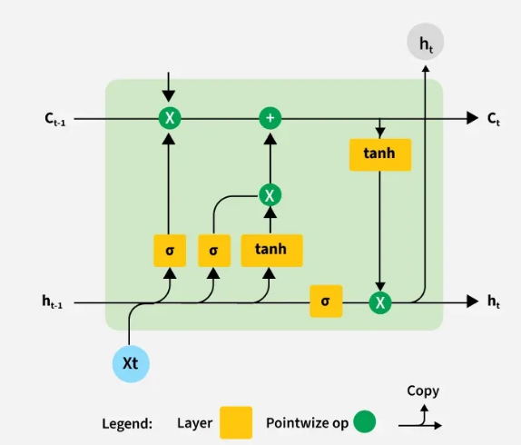
LSTM

5. Gated Recurrent Units (GRUs)
Gated Recurrent Units (GRUs) is the second usual variant of RNNs which is working on gating mechanism just like LSTM but with little parameter.
- Advantages: Vanishing gradient issue is addressed and it is compute-efficient than LSTM.
- Applications: LSTM is also involved in tasks that can be categorized as similar to speech recognition and text monitoring.
- When to use: Use when LSTM-like performance is needed but with lower computational cost.
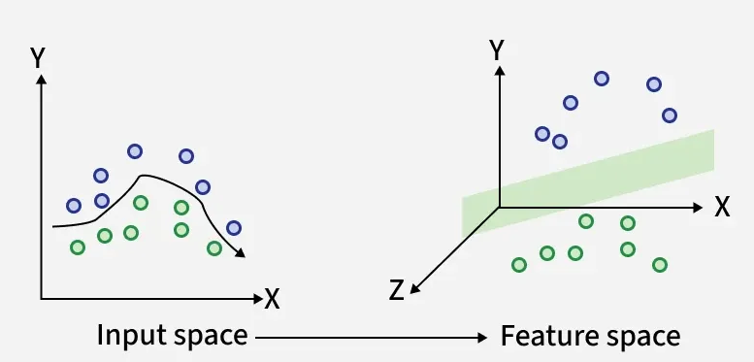
Gated Recurrent Units (GRUs)

6. Radial Basis Function Networks (RBFNs)
Radial basis function (RBF) networks are neural networks that use radial basis functions to model complex relationships, making them effective for function approximation and classification.
- Applications: Used in regression, pattern recognition and control systems.
- When to use: Suitable for function approximation and small to medium-scale classification tasks.
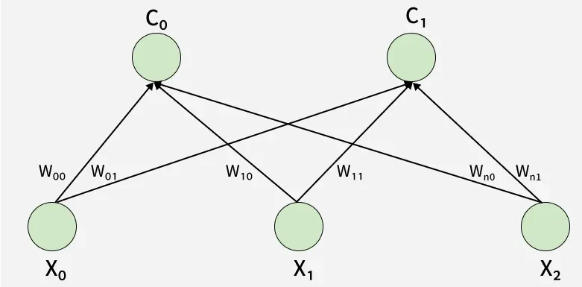
RBFNs

7. Self-Organizing Maps (SOMs)
Self-Organizing Maps are unsupervised neural networks that cluster high-dimensional data while preserving its structure, mapping it into a lower-dimensional space.
- Features: Reduce data dimensions while maintaining the underlying relationships.
- Applications: Data visualization, customer segmentation, anomaly detection and feature selection.
- When to use: Ideal for data visualization, clustering and dimensionality reduction.
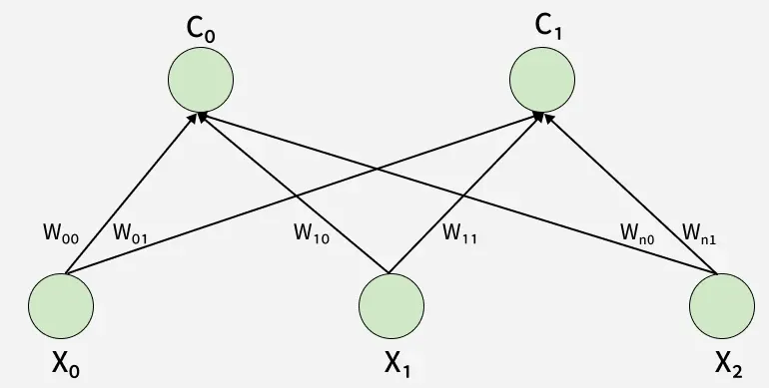
SOMs

8. Deep Belief Networks (DBNs)
Deep Belief Networks are composed of multiple layers of stochastic hidden variables, enabling both supervised and unsupervised learning, especially for complex feature extraction.
- Function: Learn hierarchical representations that improve classification performance.
- Applications: Image and voice recognition, natural language understanding and smart devices as recommendations systems.
- When to use: Suitable for unsupervised pre-training and deep feature extraction tasks.

9. Generative Adversarial Networks (GANs)
Generative Adversarial Networks consist of two models—a generator and a discriminator that compete with each other. The generator creates synthetic data, while the discriminator distinguishes between real and fake data.
- Working Principle: Both models improve through training, with the generator producing more realistic data and the discriminator becoming better at detection.
- Applications: Data generation, data augmentation, style transfer and unsupervised learning.
- When to use: Suitable for generating realistic synthetic data.
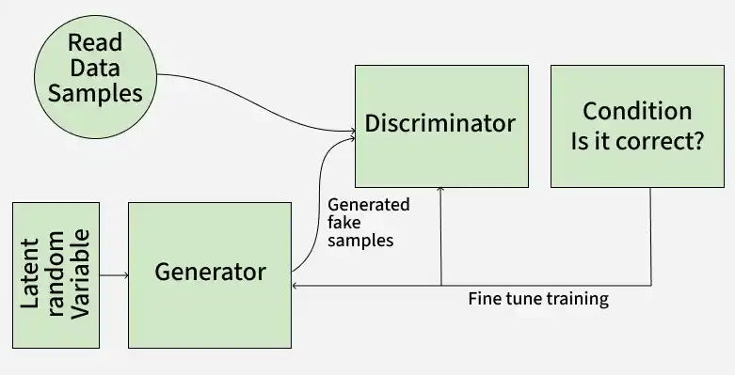
GAN

10. Autoencoders (AE)
Autoencoders are feedforward neural networks that learn efficient representations by encoding input data into a latent space and then reconstructing it. The encoder maps the input to a compressed representation, while the decoder reconstructs it.
- Functionality: Used for dimensionality reduction, feature extraction, noise removal and generative modeling.
- Types: Include undercomplete, overcomplete and variational autoencoders.
- When to use: Suitable for unsupervised tasks like data compression, denoising and anomaly detection.
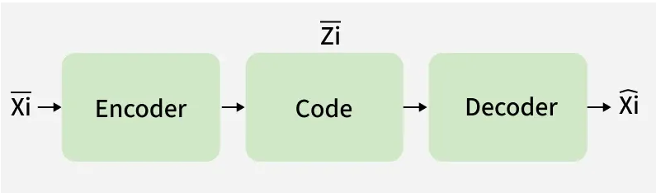
Autoencoders

11. Transformer Networks
Transformer Networks do this by way of self-attention mechanism which results into a parallel process used for making the tokenization inputs faster and thus improved capturing of long range dependencies.
- Key Features: High performance in handling language tasks, especially for translation, text generation and summarization.
- Applications: Widely used in natural language processing, as well as image and audio tasks.
- When to use: Used for NLP tasks like translation, text generation and summarization.
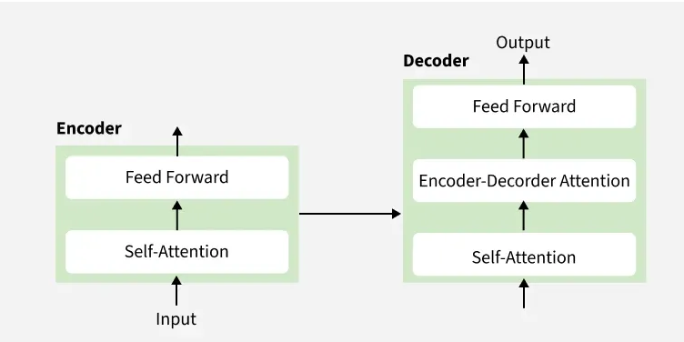
Transformer Network

12. Siamese Neural Networks
Siamese Neural Network consist of two identical networks that share the same architecture and weights. They compare two inputs using a similarity metric to determine how alike they are.
- Applications: Face recognition, signature verification, image similarity and information retrieval.
- When to use: Ideal when comparing two inputs to determine similarity like face verification.

13. Capsule Networks (CapsNet)
Capsule Networks capture spatial and hierarchical relationships in data by passing information from lower to higher layers, preserving part-to-whole structures.
- Applications: Image classification, object detection and scene understanding via the immense visual data exposure.
- When to use: Use for image classification where part-to-whole relationships matter.

14. Spiking Neural Networks (SNN)
Spiking Neural Networks (SNNs) are inspired by brain activity, where neurons communicate through discrete signals called spikes, closely mimicking biological processing.
- Applications: Neuromorphic computing, cognitive modeling and brain-inspired learning systems.
- When to use: Used when working on neuromorphic computing and biologically inspired architectures.

Introduction to Artificial Neural Networks and its Applications

Artificial Neural Networks (ANNs) are the fundamental building blocks of modern deep learning systems. They consist of interconnected artificial neurons organized into layers that learn from training data to recognize patterns, make predictions and solve complex problems.
- Organized into input, hidden and output layers
- Learn by adjusting weights and biases during training
- Process data through forward propagation and improve using backpropagation
- Support tasks such as classification, regression and prediction
- Form the foundation of advanced deep learning architectures such as CNNs, RNNs and Transformers
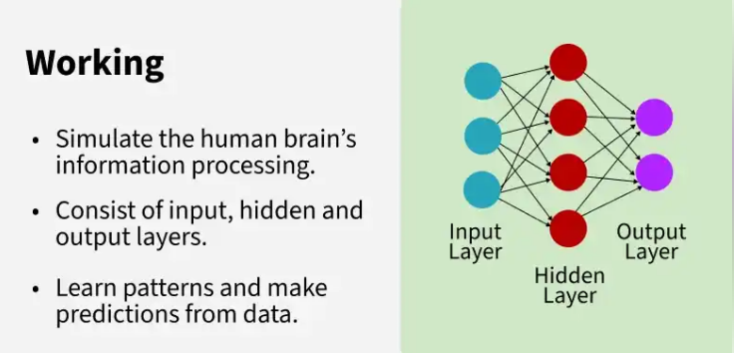
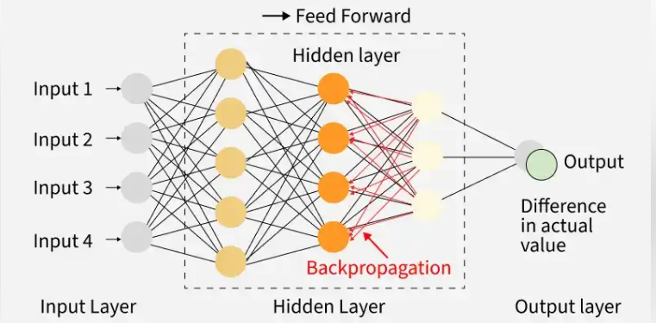
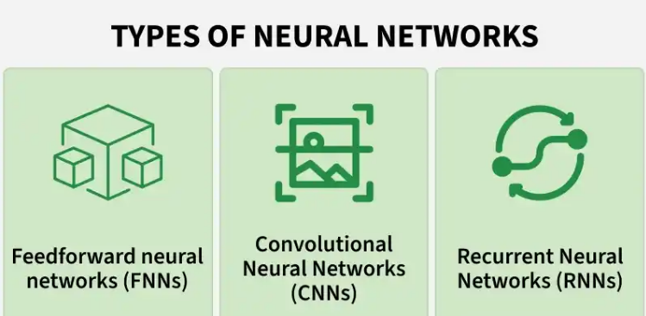
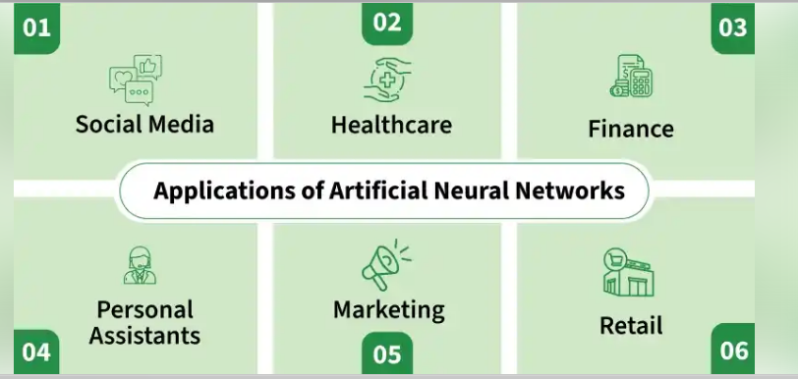

McCulloch-Pitts Model of Neuron
One of the earliest models of artificial neurons was the McCulloch-Pitts Model introduced in 1943. It is also known as the linear threshold gate.
- The neuron takes multiple inputs, each associated with a weight.
- A weighted sum of the inputs is calculated.
- If the weighted sum exceeds a threshold, the neuron fires (output = 1) otherwise it does not fire (output = 0).
Mathematically this is represented as:
�(�in)={1,if �in≥Θ0,if �in<Θf(yin​)={1,0,​if yin​≥Θif yin​<Θ​
where ������​yinyin​ is the weighted sum of inputs:
�in=∑����yin​=∑xi​wi​
This model laid the foundation for modern neural networks, though it is limited to solving only linearly separable problems.
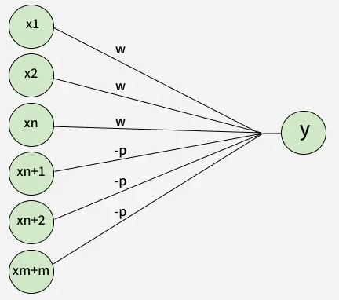
Perceptron model with excitatory (positive) and inhibitory (negative) weights

Artificial Neural Networks Algorithm

1. Initialize Weights and Bias
- The algorithm starts by initializing the weights i.e the strength of connections between neurons and biases which is additional parameters that help to adjust output.
- These values are usually initialized randomly.
- You also set the learning rate (α) which controls how much the weights should be adjusted during training.

2. Feed Input Data
The input data is fed into the input layer of the network. Each input is a feature like an image pixel, a value from a dataset, etc.

3. Forward Propagation (Calculate Output)
- The data is passed through the network from the input layer to the hidden layers and finally to the output layer.
- At each layer the input is multiplied by the weights and passed through an activation function like sigmoid, ReLU, etc to produce the output of that layer.
- The result is a prediction or an output that is compared to the actual target value.

4. Calculate Error
Once the network has made a prediction the next step is to calculate the error i.e the difference between the predicted output and the actual target. This error is often measured using a loss function like Mean Squared Error or Cross-Entropy.

5. Backpropagation (Update Weights)
Backpropagation computes the gradients i.e how much change in weights would reduce the error by using the chain rule of calculus. The weights and biases are then updated to minimize the error. The update is done using an optimization algorithm like Gradient Descent:
�=�−�×∂Error∂�w=w−α×∂w∂Error​

6. Repeat (Epochs)
Steps 2 to 5 are repeated for multiple epochs which is iterations over the entire training dataset. During each epoch the weights are adjusted to reduce the error gradually.

7. Test the Network
After training, the network is tested with new data to evaluate its performance. If the accuracy is good, the training is considered complete. If not more training or adjustments may be needed.

How do Artificial Neural Networks learn?
Artificial Neural Networks learn by repeatedly improving their predictions from training examples. Consider the task of recognizing cats in images.
- The network is trained using thousands of labeled images of cats and non-cats.
- Each image passes through the network to generate a prediction.
- The predicted result is compared with the correct label to calculate the error.
- The network updates its weights and biases to reduce this error.
- This process is repeated over many training iterations until the network can accurately classify new images.

Common Activation Functions in ANNs
Activation functions are important in neural networks because they introduce non-linearity and helps the network to learn complex patterns. Lets see some common activation functions used in ANNs:
- Sigmoid Function: Outputs values between 0 and 1. It is used in binary classification tasks like deciding if an image is a cat or not.
- ReLU (Rectified Linear Unit): A popular choice for hidden layers, it returns the input if positive and zero otherwise. It helps to solve the vanishing gradient problem.
- Tanh (Hyperbolic Tangent): Similar to sigmoid but outputs values between -1 and 1. It is used in hidden layers when a broader range of outputs is needed.
- Softmax: Converts raw outputs into probabilities used in the final layer of a network for multi-class classification tasks.
- Leaky ReLU: A variant of ReLU that allows small negative values for inputs helps in preventing “dead neurons” during training.
These functions help the network decide whether to activate a neuron helps it to recognize patterns and make predictions.

Optimization Algorithms in ANN Training
Optimization algorithms adjust the weights of a neural network during training to minimize errors. The goal is to make the network’s predictions more accurate. Lets see key algorithms:
- Gradient Descent: Most basic optimization algorithm that updates weights by calculating the gradient of the loss function.
- Adam (Adaptive Moment Estimation): An efficient version of gradient descent that adapts learning rates for each weight used in deep learning.
- RMSprop: A variation of gradient descent that adjusts the learning rate based on the average of recent gradients, it is useful in training recurrent neural networks (RNNs).
- Stochastic Gradient Descent (SGD): Updates weights using one sample at a time helps in making it faster but more noisy.
For more details refer to Optimization Algorithms in ANN

Applications
- Classification: ANNs are widely used for tasks such as spam email detection, fraud detection, sentiment analysis, and customer churn prediction.
- Regression: They predict continuous values such as house prices, sales forecasts, stock trends, and energy consumption.
- Healthcare: ANNs assist in disease diagnosis, medical data analysis, and predicting patient health risks.
- Business and Recommendation Systems: They help recommend products, personalize user experiences, and analyze customer behavior for better decision-making.

Advantages
- Handle noisy and incomplete data without affecting their performance. Even if there are errors in the training data they can still produce accurate results.
- Once trained ANNs can evaluate functions very quickly making them ideal for real-time applications like self-driving cars or fraud detection.
- Handle large amounts of data through distributed processing similar to how the human brain works.

Limitations
- Can overfit to training data especially when the model is too complex or when there is insufficient data.
- Require large datasets for training to generalize well.
- Training deep neural networks can be computationally expensive and time-consuming hence requiring substantial hardware resources.

Activation Functions in Pytorch

What is an activation function and why to use them?
Activation functions are the building blocks of Pytorch. Before coming to types of activation function, let us first understand the working of neurons in the human brain. In the Artificial Neural Networks, we have an input layer which is the input by the user in some format, a hidden layer that performs the hidden calculations and identifies features and output is the result. So the whole structure is like a network with neurons connected to one another. So we have artificial neurons which are activated by these activation functions. The activation function is a function that performs calculations to provide an output that may act as input for the next neurons. An ideal activation function should handle non-linear relationships by using the linear concepts and it should be differentiable so as to reduce the errors and adjust the weights accordingly. All activation functions are present in the torch.nn library.

Types of Pytorch Activation Function
Let us look at the different Pytorch Activation functions:
- ReLU Activation Function
- Leaky ReLU Activation Function
- Sigmoid Activation Function
- Tanh Activation Function
- Softmax Activation Function

ReLU Activation Function:
ReLU stands for Rectified Linear Activation function. It is a non-linear function and, graphically ReLU has the following transformative behavior:
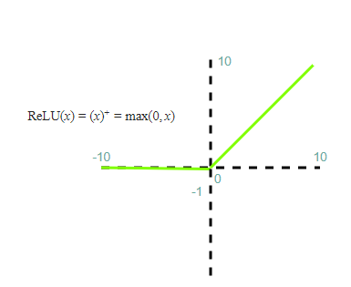
ReLU is a popular activation function since it is differentiable and nonlinear. If the inputs are negative its derivative becomes zero which causes the 'dying' of neurons and learning doesn't take place. Let us illustrate the use of ReLU with the help of the Python program.

Leaky ReLU Activation Function:
Leaky ReLU Activation Function or LReLU is another type of activation function which is similar to ReLU but solves the problem of 'dying' neurons and, graphically Leaky ReLU has the following transformative behavior:
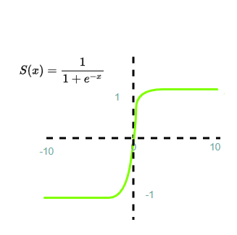
This function is very useful as when the input is negative the differentiation of the function is not zero. Hence the learning of neurons doesn't stop. Let us illustrate the use of LReLU with the help of the Python program.

Sigmoid Activation Function:
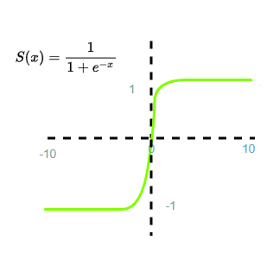
Sigmoid Function is a non-linear and differentiable activation function. It is an S-shaped curve that does not pass through the origin. It produces an output that lies between 0 and 1. The output values are often treated as a probability. It is often used for binary classification. It is slow in computation and, graphically Sigmoid has the following transformative behavior:

Sigmoid activation function has a problem of "Vanishing Gradient". Vanishing Gradient is a significant problem as a large number of inputs are fed to the neural network and the number of hidden layers increases, the gradient or derivative becomes close to zero thus leading to inaccuracy in the neural network.
Let us illustrate the use of the Sigmoid function with the help of a Python Program.

Tanh Activation Function:
Tanh function is a non-linear and differentiable function similar to the sigmoid function but output values range from -1 to +1. It is an S-shaped curve that passes through the origin and, graphically Tanh has the following transformative behavior:
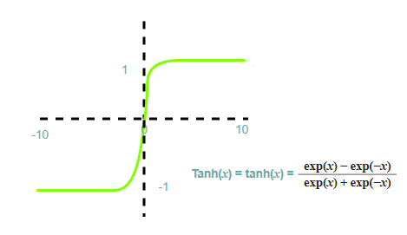
The problem with the Tanh Activation function is it is slow and the vanishing gradient problem persists. Let us illustrate the use of the Tanh function with the help of a Python Program.

Softmax Activation Function:
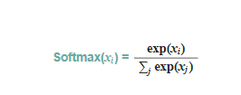
The softmax function is different from other activation functions as it is placed at the last to normalize the output. We can use other activation functions in combination with Softmax to produce the output in probabilistic form. It is used in multiclass classification and generates an output of probabilities whose sum is 1. The range of output lies between 0 and 1. Softmax has the following transformative behavior:

Neural Network Architectures

Neural network architectures define the structural design of deep learning models, shaping how they process information, learn patterns and make predictions. From simple feed-forward networks to advanced architectures like CNNs, RNNs, Transformers and hybrid models, each architecture is tailored to specific types of data and tasks.
- Different architectures excel in vision, language, time-series and generative tasks
- The choice of architecture directly impacts performance, efficiency and accuracy

1. Single-Layer Feed-Forward Network
A single-layer feed-forward network connects input neurons directly to output neurons through a single set of weights. It does not contain hidden layers or feedback connections and information flows only in the forward direction. This architecture is suitable only for linearly separable problems.
- Contains only one trainable weight layer.
- Information flows strictly in one direction.
- Computationally efficient and simple to implement.
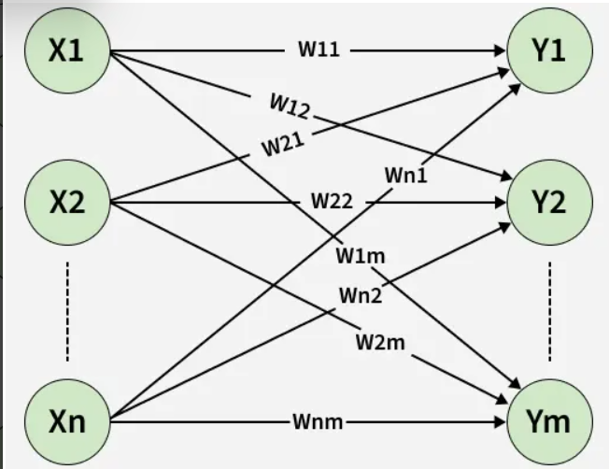
Single-Layer Feed-Forward Network

Working
- Input features are provided to the network.
- Each input is multiplied by its corresponding weight.
- A bias term is added to the weighted sum.
- The result passes through an activation function.
- The activated value produces the final output.

Use Cases
- Binary Classification: Problems such as yes/no or true/false predictions.
- Linear Regression Tasks: Predicting values with linear relationships.
- Threshold-Based Decision Systems: Simple rule-based classifiers.
- Educational Models: Demonstrating basic neural learning principles.

2. Multilayer Feed-Forward Network
A multilayer feed-forward network consists of an input layer, one or more hidden layers and an output layer. The presence of hidden layers with nonlinear activation functions enables learning of complex, non-linear mappings. Data propagation occurs strictly from input to output.
- Includes hidden layers with nonlinear activations.
- Learns hierarchical feature representations.
- Uses backpropagation for learning.
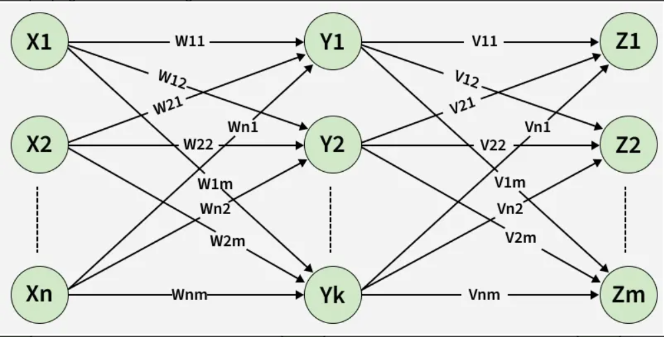
Multilayer Feed-Forward Network

Working
- Input data enters the input layer.
- Signals are forwarded to the first hidden layer.
- Each neuron computes a weighted sum and applies activation.
- Outputs flow sequentially through all hidden layers.
- The output layer generates the final prediction.
- Prediction error is computed.
- Error is propagated backward to update weights.

Use Cases
- Image Classification: Identifying objects in images.
- Medical Diagnosis: Disease prediction based on patient data.
- Fraud Detection: Identifying abnormal financial behavior.
- Pattern Recognition: Learning complex input-output mappings.

3. Single Node with Its Own Feedback
A single node with its own feedback is a simple recurrent structure where a neuron’s output is fed back as an input in the next time step. This feedback introduces a basic memory mechanism. The output depends on both current input and previous output.
- Simplest form of recurrence.
- Introduces temporal dependency.
- Maintains a single internal state.
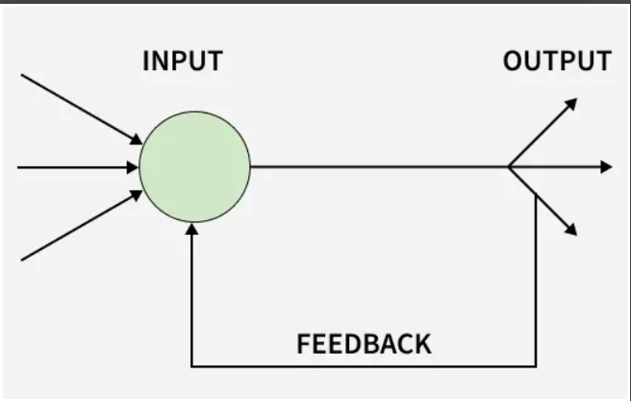
Single Node with Its Own Feedback

Working
- Input is combined with the previous output.
- The combined signal is weighted and summed.
- An activation function produces the current output.
- The output is stored as feedback.
- Feedback is used in the next time step’s computation.

Use Cases
- Dynamic System Modeling: Representing systems that evolve over time.
- Signal Filtering: Smoothing fluctuating signals.
- Control Systems: Adaptive decision mechanisms.
- Introductory Temporal Models: Learning basic time-dependent behavior.

4. Single-Layer Recurrent Network
A single-layer recurrent network contains one layer of neurons with feedback connections. These connections allow the network to maintain a hidden state across time steps. It is primarily used for modeling sequential and time-dependent data.
- Feedback connections create temporal memory.
- Processes data step-by-step in time.
- Hidden state stores past information.
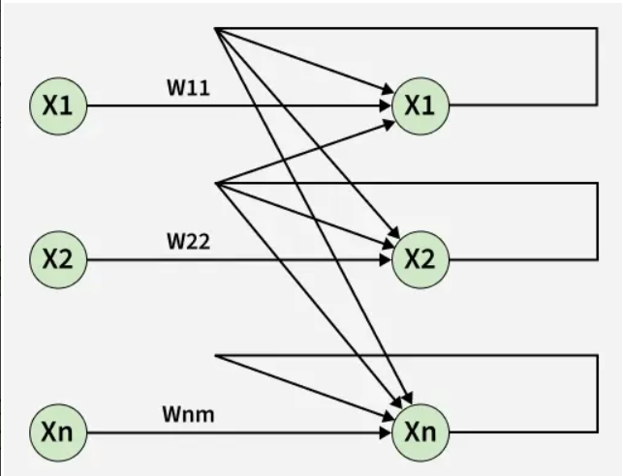
Single-Layer Recurrent Network

Working
- Input at the current time step is received.
- Previous hidden state is retrieved.
- Current input and past state are combined.
- Weighted sum and activation update the hidden state.
- Output is generated for the current time step.
- Hidden state is passed to the next time step.

Use Cases
- Time-Series Prediction: Forecasting stock prices or weather.
- Sequential Pattern Learning: Detecting temporal trends.
- Speech Processing: Modeling speech signals.
- Sensor Data Analysis: Processing streaming data.

5. Multilayer Recurrent Network
A multilayer recurrent network consists of multiple recurrent layers stacked together. Each layer processes temporal information while passing its hidden state to the next layer. This structure enables learning of complex and long-term temporal dependencies.
- Each layer maintains its own temporal state.
- Learns hierarchical sequence representations.
- Handles long and complex sequences effectively.

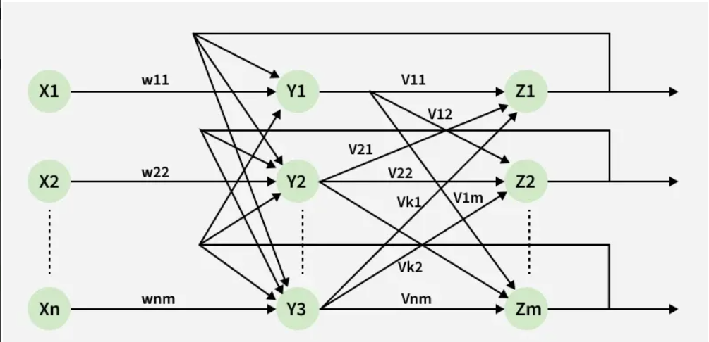
Multilayer Recurrent Network

Working
- Input sequence enters the first recurrent layer.
- Temporal patterns are learned at the first layer.
- Hidden states are passed to the next recurrent layer.
- Higher layers capture abstract temporal features.
- Final recurrent layer produces output.
- Errors are propagated backward through time.
- Weights are updated across all layers.

Use Cases
- Natural Language Processing: Text generation and translation.
- Speech Recognition: Converting speech to text.
- Video Sequence Analysis: Understanding motion patterns.
- Financial Forecasting: Long-term market trend analysis.

Comparison of Neural Network Architectures
Let's compare the various types of architectures:
Aspect | Single-Layer Feed-Forward | Multilayer Feed-Forward | Single Node with Feedback | Single-Layer Recurrent | Multilayer Recurrent
Presence of Hidden Layers | No hidden layers | One or more hidden layers | No hidden layers | One recurrent layer | Multiple recurrent layers
Feedback Connections | Absent | Absent | Self-feedback only | Present within layer | Present across layers
Memory Capacity | No memory | No memory | Very limited memory | Short-term memory | Short- and long-term memory
Training Complexity | Very low | Moderate | Very low | High | Very high
Parameter Count | Minimal | Moderate to high | Minimal | Moderate | Very high
Parallel Processing Ability | Fully parallel | Fully parallel | Limited | Limited | Very limited

